There are 2 reasons why people mint stablecoins by loaning out their volatile cryptocurrencies in return for stable coins

1. They want to stay long in volatile crypto without need excess leverage also to explore other yields in the market
2. They want to take advantage of peg offbalance specially when stablecoin is above peg. This way they can borrow stablecoins and 1USD and sell it at a market price where stablecoin is above peg thus exploiting arbitrage to make some gains

That’s why we don’t want our protocol to just mint stablecoin by exchanging some volatile crypto. We want to provide both of those opportunities mentioned above.

Stakeholders in Protocol

1. Borrower – Borrows stable coin by putting Ethereum as Collateral
2. CDS owner – Deposits stablecoin for collateral downside protection
3. Protocol – Protocol has to ensure peg of stablecoin and capture fees

Tokens in Protocol

1. Stablecoin
2. Option
3. Hedging/ BondsToken (generated when CDS owner loses money)

How the protocol works

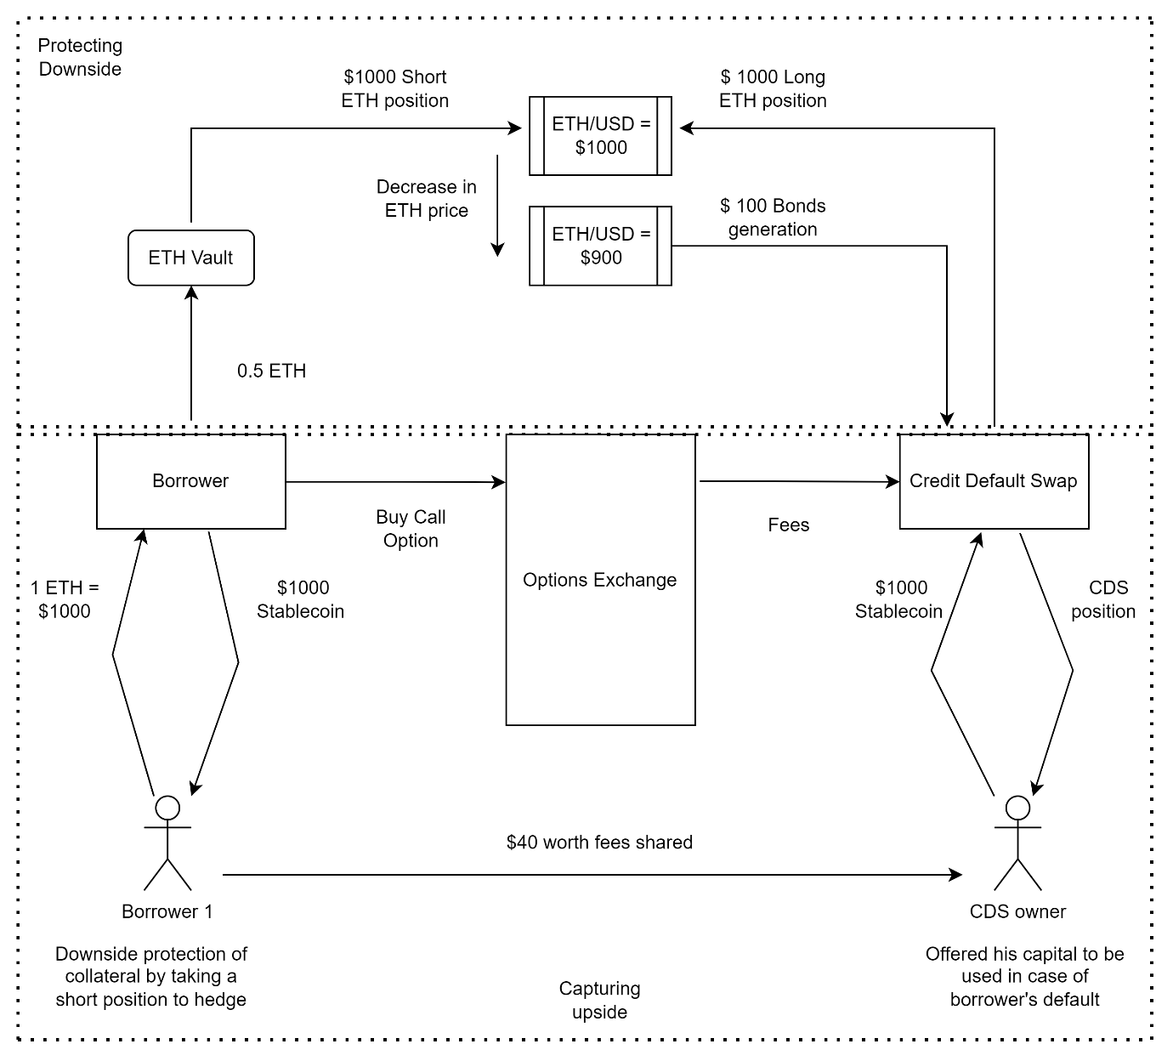

The Borrower borrows stablecoin against collateral deposited. The Collateral ETH is deposited into the ETH Vault. Also, on the other side CDS owner deposits stablecoin to be utilized in case of borrower’s default.

Protocol now in order to give downside protection of collateral to borrower will engage in a short position using ETH in ETH vault on the ETH/USD price. On the other side, Protocol will take CDS stablecoin deposits and put them in a long position on the ETH/USD price.

Now, if the ETH value decreases then the short position will profit by similar increase in value after deduction of same amount from Long position.

Also, If ETH value increases, then the long position will profit by similar increase in value after deduction of same amount from short position. However, due to rise in ETH price in ETH vault, it creates a net neutral strategy for short position taker thus offering him downside protection as well as upside limitation.

Here, the deposits of stablecoin will be locked for 1 month duration.

Also, CDS owners will be getting option fees from borrowers in return for offering their stablecoin deposits to offer downside protection from borrowers.

Since, the fees offered might be less to CDS owners so we will be generating a new token called bond/hedge token which will be given to CDS once they unlock their deposit after 1 month. This bond/hedge token will have a maturity of 6 months. 1 bond/ hedge token is equivalent to 100 stablecoins at maturity after 6 months. So, after 6 months, CDS owner can use this bond/hedge token to get the full value (100 stablecoins ). This bond/ hedge token can also be traded before the maturity with other participants.

Below listed are 2 scenarios mentioned where ETH price increases in 100USD increment and ETH price decreased in 100USD decrement.

1. ETH price incrementing by 100USD increment

|  |  |  |  |  |  |  |  |
| --- | --- | --- | --- | --- | --- | --- | --- |
| ETH Price |  | 1000 | 1100 | 1200 | 1300 | 1400 |  |
|  | Short Position | | | | | |  |
|  | Borrower | D1 | D2 | D3 | D4 | D5 |  |
|  | B1 | 1000 | 900 | 800 | 700 | 600 |  |
|  | B2 |  | 1100 | 1000 | 900 | 700 |  |
|  | B3 |  |  | 1200 | 1100 | 1000 |  |
|  | B4 |  |  |  | 1300 | 1200 |  |
|  | B5 |  |  |  |  | 1400 |  |

|  |  |  |  |  |  |
| --- | --- | --- | --- | --- | --- |
| Long Position | | | | | |
| CDS | D1 | D2 | D3 | D4 | D5 |
| CDS1 | 2000 | 2100 | 2300 | 2000 | 2500 |
| CDS2 |
| Bonds minted |  | 0 | 0 | 0 | 0 |

1. ETH price decreasing by 100USD decrement

|  |  |  |  |  |  |  |  |
| --- | --- | --- | --- | --- | --- | --- | --- |
| ETH Price |  | 1000 | 900 | 800 | 700 | 600 |  |
|  | Short Position | | | | | |  |
|  | Borrower | D1 | D2 | D3 | D4 | D5 |  |
|  | B1 | 1000 | 1100 | 1200 | 1300 | 1400 |  |
|  | B2 |  | 900 | 1000 | 1100 | 1200 |  |
|  | B3 |  |  | 800 | 900 | 1000 |  |
|  | B4 |  |  |  | 700 | 800 |  |
|  | B5 |  |  |  |  | 600 |  |

|  |  |  |  |  |  |
| --- | --- | --- | --- | --- | --- |
| Long Position | | | | | |
| CDS | D1 | D2 | D3 | D4 | D5 |
| CDS1 | 2000 | 1900 | 1700 | 1400 | 1000 |
| CDS2 |
| Bonds minted | 0 | 100 | 200 | 300 | 400 |
| Total Bonds minted | | 100 | 300 | 600 | 1000 |